# CelDial: Case Study Analysis

### INTRODUCTION

Celdial Corporation is a Telecommunication enterprise which started out as a manufacturer of cell phones but grew to manufacture a broad range of telecommunication products. Hence, it opened its own sales outlets. So, now with the expansion of the company, Celdial needs to put its efforts into revamping the sales and increasing the capacity of the inventory.

### OBJECTIVE

Objective of this project is to create a Data Warehouse and perform analysis on Cost and Revenue. The two systems are defined as

### Operational System

Users of an operational system turn the wheels of the organization. They take orders, sign up new customers, monitor the status of operational activities and log complaints. The operational systems are optimized to process transactions quickly. These systems almost always deal with one transaction record at a time. They predictably perform the same operational tasks over and over, executing the organization’s business processes. Given this execution focus, operational systems typically do not maintain history, but rather update data to reﬂect the most current state.

### Data warehouse System

Users of a DW/BI system, on the other hand, watch the wheels of the organization turn to evaluate performance. They count the new orders and compare them with last week’s orders, and ask why the new customers signed up, and what the customers complained about. They worry about whether operational processes are working correctly. Although they need detailed data to support their constantly changing questions, DW/BI users almost never deal with one transaction at a time. These systems are optimized for high-performance queries as users questions often require hundreds of thousands of transactions to be searched and compressed into an answer set. To

further complicate matters, users of a DW/BI system typically demand that historical context be preserved to accurately evaluate the organization’s performance over time**.**

### SCOPE OF THE PROJECT

The project will help the user to analyze the constant revenue of various product model manufactured by celdial. This analysis could be done on various grounds incorporating factors such as time, manufacturing region, order, inventory and sales region. The project will be limited to total cost and revenue. The manufacturing cost are calculated on the inventory level and hence the cost of the components are considered. The data warehouse will be flexible enough to accommodate in future changes. This will also enable us to know the available quantity in the inventory, the reorder level, discounts on the models, total cost and revenue on a daily weekly and monthly basis with desired granularity.

### UNDERSTANDING & ANALYZING REQUIREMENTS –

**Design Approach:**

**Conceptual Model Design**

* Data Mart chosen: Sales, Inventory
* Granularity specified: Time (week, month) , Outlet (corporate, retail)
* Dimensions: Time, Customer, Product, Employee, Manufacturing
* Facts Chosen: Sales ,Inventory

# Entity Details

|  |  |  |
| --- | --- | --- |
| **FACT TABLE** | **DIMENSION** | **No. of ATTRIBUTES** |
| **Inventory(10)** | **Manufacturing** | **4** |
| **Prod_Model** | **7** |
| **Order** | **4** |
| **Time** | **5** |
| **Components** | **3** |
| **Sales(13)** | **Order** | **4** |
| **Product_Model** | **7** |
| **Customer** | **6** |
| **Outlet** | **6** |
| **Time** | **5** |

**Logical Design: Required Trace Ability Matrix**

|  |  |  |  |
| --- | --- | --- | --- |
| **Subject Area** | **Key Business Measures** | **Granularity** | **Dimensions involved in Analysis** |
| **SALES** | **Total Revenue** | **Time: Day,Week, Month** | **Time, Order, Outlet,**  **Prod_Model, Customer** |
| **Total Sold Quantity** | **Outlet: Retailer, Corporate Sales Office** |
| **Discount** | **Product:type, Model** |
| **INVENTORY** | **Total Cost** | **Time: Day,Week, Month** | **Time, Manufacturing, Order,**  **Components, Prod_Model** |
| **Available Quantity** | **Inventory: Product type, model.** |
| **Reorder** | **Inventory: Product type, model.** |

|  |  |  |  |  |  |  |
| --- | --- | --- | --- | --- | --- | --- |
| **FACT**  **DIMENSION** | **Total sold quantity** | **Total produced quantity** | **Re-order Level** | **Total Revenue** | **Total Cost** | **Discount** |
| **Time(D)** | ✓ | ✓ | ✓ | ✓ | ✓ | ✓ |
| **Order(D)** | ✓ |  | ✓ | ✓ |  | ✓ |
| **Manufacturing(D)** |  | ✓ | ✓ |  | ✓ |  |
| **Product Model(D)** | ✓ | ✓ | ✓ | ✓ | ✓ | ✓ |
| **Inventory(F)** |  | ✓ | ✓ |  | ✓ |  |
| **Sales(F)** | ✓ |  |  | ✓ |  | ✓ |

**Physical Design:**

|  |  |  |
| --- | --- | --- |
| **DIMENSION** | **ATTRIBUTES** | **STANDARDS** |
| MANUFACTURING | REGION_ID | NUMBER(6) |
| PLANT_ID | NUMBER(5) |
| NAME | VARCHAR2(30) |
| ADDRESS | VARCHAR2(80) |
| COMPONENTS | COMPONENT_ID | NUMBER(5) |
| UNIT_COST | NUMBER(5) |
| COMPONENT_DESC | VARCHAR2(80) |
| PRODUCT MODEL | PROD_ID | NUMBER(5) |
| MOD_ID | NUMBER(5) |
| PROD_DESC | VARCHAR2(80) |

|  |  |  |
| --- | --- | --- |
|  | NO_OF_COMPONENTS | NUMBER(5) |
| SUGG_WP | NUMBER(8) |
| SUGG_RP | NUMBER(8) |
| VOLUME_DISC | CHAR(1) |
| TIME | TIME | DATE |
| DATE | DATE |
| WEEK | DATE |
| MONTH | DATE |
| OUTLET | OUTLET_ID | NUMBER(5) |
| REGION_ID | NUMBER(5) |
| SALESPERSON_ID | NUMBER(5) |
| NAME | VARCHAR2(30) |
| NO_OF_ORDER_DESKS | NUMBER(5) |

|  |  |  |
| --- | --- | --- |
|  | ADDRESS | VARCHAR2(80) |
| CUSTOMER | CUSTOMER_ID | NUMBER(5) |
| CUST_NAME | VARCHAR2(30) |
| PHONE | NUMBER(10) |
| EMAIL | VARCHAR2(50) |
| SHIPPING_ADDR | VARCHAR2(80) |
| BILLING_ADDR | VARCHAR2(80) |
| ORDER | ORDER_ID | NUMBER(5) |
| PRODUCT_ID | NUMBER(5) |
| MODEL_ID | NUMBER(5) |
| QUANTITY | NUMBER(5) |

**Operational to Dimensional Model**

# MAP:

|  |
| --- |
| **Manufacturing Plant** |
| Region_ID |
| Plant_ID |
| Name |
| Address |

|  |
| --- |
| **Manufacturing** |
| Region_ID |
| Plant_ID |
| Name |
| Address |

|  |
| --- |
| **Component** |
| Component_ID |
| Component_Desc |
| Unit_Cost |

|  |
| --- |
| **Component** |
| Component_ID |
| Component_Desc |
| Unit_Cost |

|  |
| --- |
| **Customer** |
| Customer_ID |
| Name |
| Salesperson_ID |
| Phone |
| Address |
| E-mail_address |

|  |
| --- |
| **Customer** |
| Customer_ID |
| Cust_Name |
| Phone |
| E-mail |
| Shipping Address |
| Billing Address |

|  |
| --- |
| **Customer Shipment** |
| Customer_ID |
| Customer_Shipment_address |
| Customer_Billing_address |

|  |
| --- |
| **Order** |
| Region_ID |
| Outlet_ID |
| Order_ID |
| Order_Date |
| Order_Status |
| Customer_ID |
| Salesperson_ID |

|  |
| --- |
| **Order Details** |
| Plant_ID |
| Outlet_ID |
| Order_ID |
| Product_ID |
| Model_ID |
| Quantity |

|  |
| --- |
| **Order** |
| Order_ID |
| Product_ID |
| Model_ID |
| Quantity |

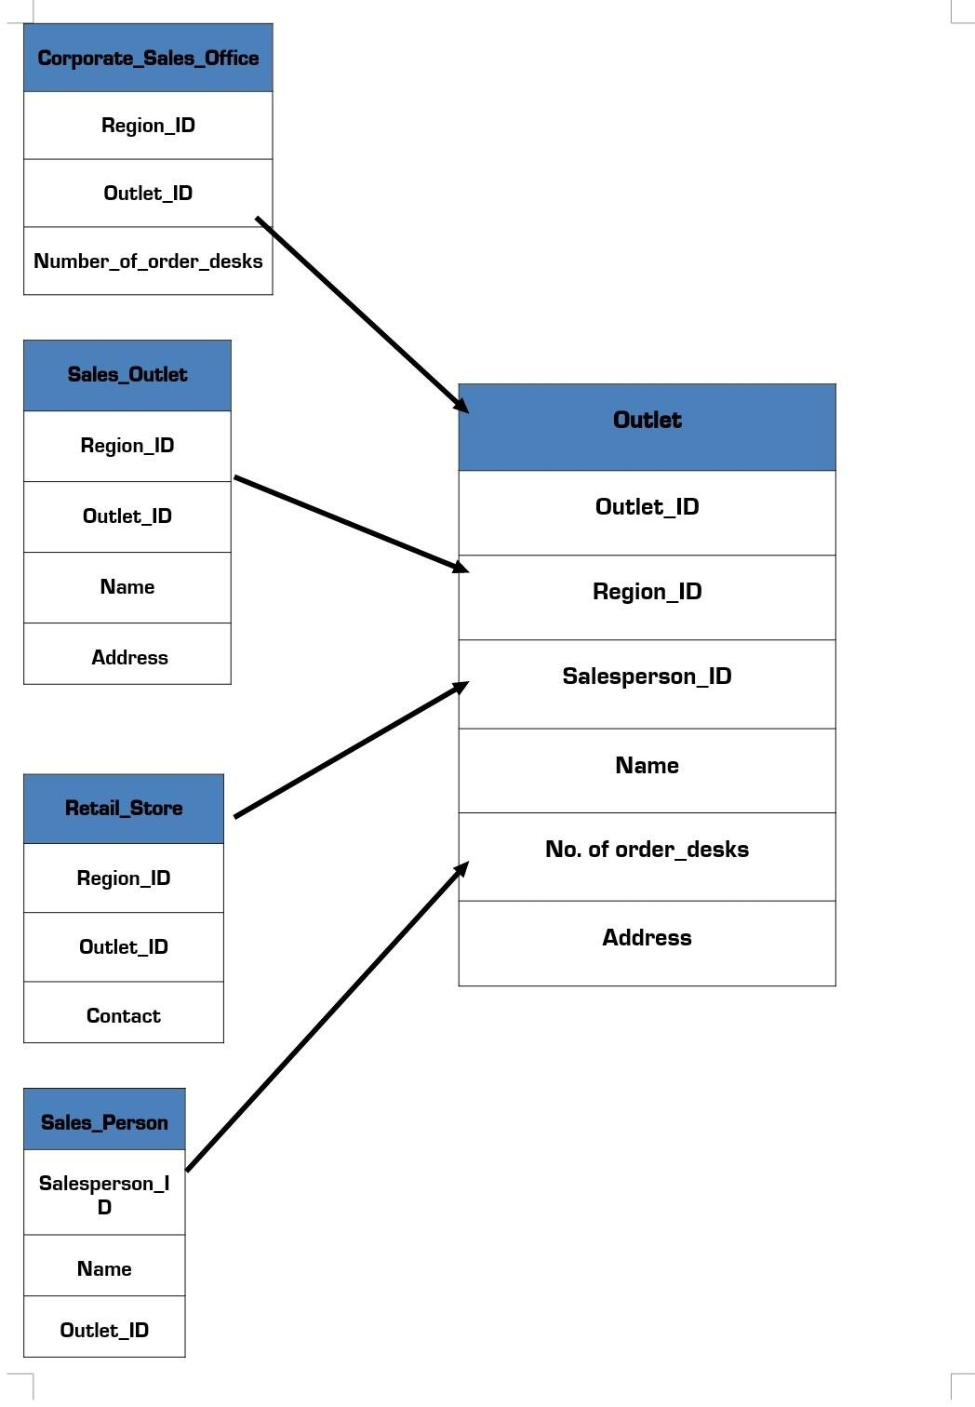

## Time

**Dimension Model**

Time (PK) Date Week Month Year

## Outlet

Outlet ID (PK) Region_ID Salesperson_ID Name No_of_order_desks Address

**Manufacturing**

Plant_ID (PK) Region_ID Name Address

**Inventory**

Region_ID (FK) Plant_ID (FK) Component_ID (FK) Product_ID (FK) Model_ID (FK) Order_ID (FK) Time (FK) Available Quantity Reorder

Total Cost

**Order**

Order_ID (PK) Product_ID Model_ID Quantity

**Sales**

Order_ID (FK) Product_ID (FK) Model_ID (FK) Region_ID (FK) Salesperson_ID (FK) Customer_ID (FK) Time (FK)

Total Sold Quantity Daily Revenue Weekly Revenue Monthly Revenue Total Revenue Discount

Group 2:-

Component_ID (PK) Unit_Cost

Component_Desc

**Components**

**Customer**

Customer_ID (PK) Cust_Name

Phone E-mail

Shipping Address Billing Address

**Product Model**

Prodcut_ID (PK) Model_ID (PK) Product_Desc

No. of Components Suggested_WP Suggested_RP Volume_Disc

Altamash Shahid

Satya Sourav Mohanty